There are times when a relationship itself has associated properties, especially when its classes share a many-to-many relationship. In these cases, a class called an association class is formed, which has its own attributes. It is shown as a rectangle attached "by a dashed line to the association path, and the rectangle’s name matches the label of the association. Think about the case of capturing information about illnesses and symptoms. An illness (e.g., the flu) can be associated with many symptoms (e.g., sore throat, fever), and a symptom (e.g., sore throat) can be associated with many illnesses (e.g., the flu, strep throat, the common cold). Figure 1 shows how an association class can capture information about remedies that change depending on the various combinations. For example, a sore throat caused by strep throat requires antibiotics, whereas treatment for a sore throat from the flu or a cold could be throat lozenges or hot tea.

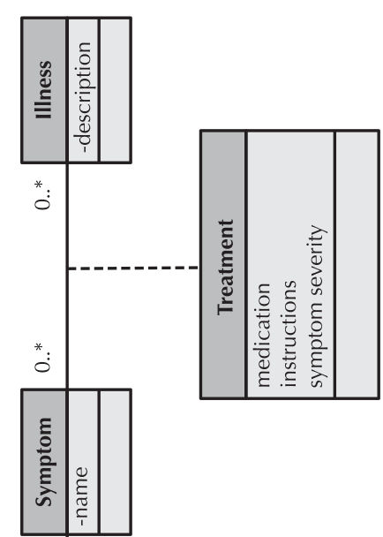

Figure 1

Another way to decide when to use an association class is when attributes that belong to the intersection of the two classes involved in the association must be captured. We can visually think about an association class as a Venn diagram. For example, in Figure 2, the Grade idea is really an intersection of the Student and Course classes, because a grade exists only at the intersection of these two ideas. Another example shown in Figure 2 is that a job may be viewed as the intersection between a Person and a Company.

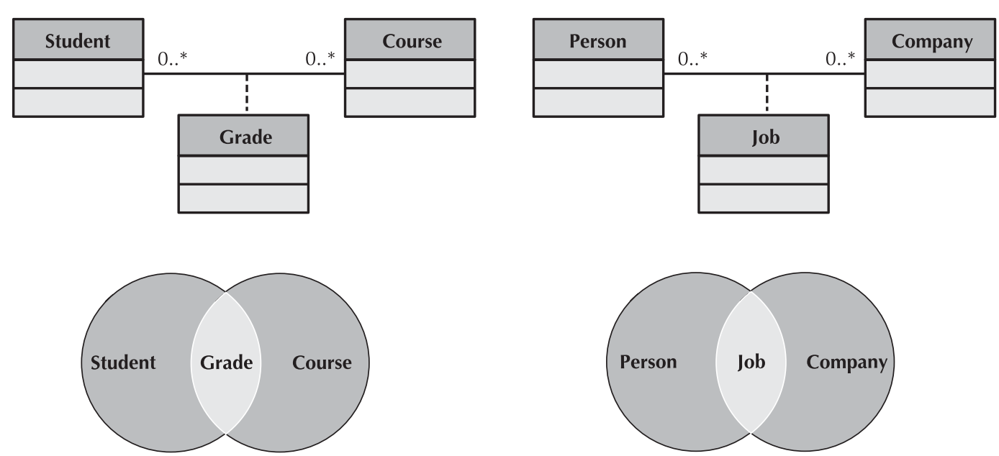

Figure 2